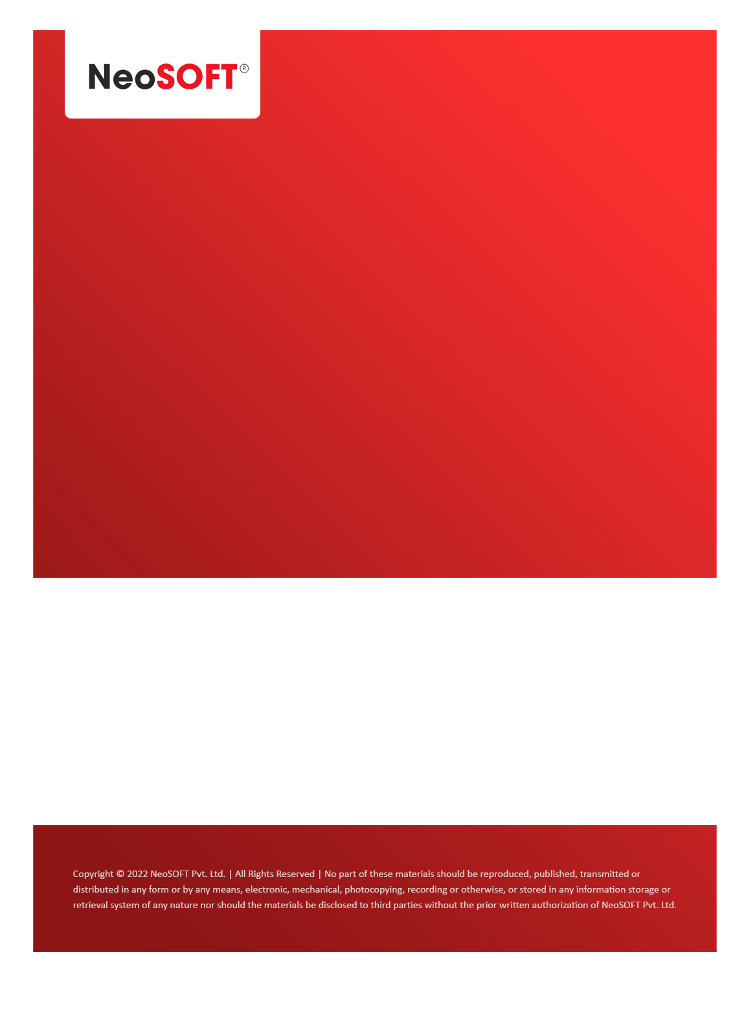`

**MOM – Project updates**

Eltizam

Client Name

NeoSOFT is a SEI-CMMI Level-5 Global IT Consulting & Software Solutions Provider

**5th Oct,** 2023

|  |  |
| --- | --- |
| **Meeting Date, Time, and Attendee Details** | |
| **Date** | 5th October 2023 |
| **Venue** | MS Teams |
| **Time** | 04.00 PM – 04.30 PM IST |
| **Meeting Type** | Project status discussions |
| **Internal Attendees** | * YallaReddy * Pawan Kumar |
| **Client Attendees** | * Karuna Pawar |
| **MOM Prepared By** | * YallaReddy |

|  |  |
| --- | --- |
| **Details of Meeting** | |
| **Sr. No.** | **Description** |
| 1 | Discussed project status on application developers, HTML development. |
| 2 | Showed HTML pages for master modules and showed development login, Resource master list page. |
| 3 | Received minor feedback changes and we will add them in design. |
| 4 | We will continue with work on website development. |
|  |  |

|  |  |  |  |  |  |
| --- | --- | --- | --- | --- | --- |
| **Actionable** | | | | | |
| **Sr. No.** | **Action Item** | **Assigned to** | **Assigned Date** | **Expected Completion Date** | **Status** |
| 1 |  |  |  |  |  |
| 2 |  |  |  |  |  |
| 3 |  |  |  |  |  |